HOLY CROSS CONVENT SENIOR SECONDARY SCHOOL,AMBIKAPUR

CLASS - IV
SUBJECT - ENGLISH GRAMMAR

Note: Students are instructed to write the following notes in their English grammar book with pencil.
Students not having the book can practice it in their English practice copy.

- NOUNS - COLLECTIVE

- Collective nouns-
Collective nouns are the names used for collections of common nouns ; as-

- Our class has thirty - five students.
- The fox looked at the ripe bunch of grapes.

In the above sentences class and bunch are names of collections. So, they are collective nouns.

A collective noun is the name given to a group of common nouns.

Learn these collective nouns :

- PEOPLE

- An army of soldiers
- A bond of robbers
- A mob of people
- A team of players
- A crowd of onlookers
- A board of directors
- A class of students
- A company of actors

- ANIMALS

- A pack of wolves, hounds | - A litter of pups, cups
- A herd of cattle | - A pride of lions
- A flight of birds | - A shoal of fish
- A flock of sheep, goats | - A swarm of bees

- GENERAL

- A bunch of keys | - A pack of cards
- A library of books | - A cluster of stars
- A flight of steps | - A set of crockery
- A grove of trees | - A suit of clothes

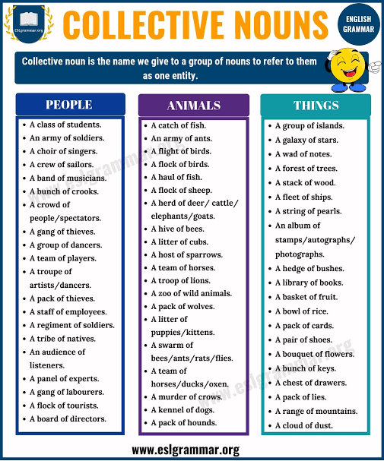

WORKSHEET

- What is a collective noun? Give four examples.
Answer - A collective noun is the name given to a group of common nouns.
Example -
- A bouquet of flowers.
- A shoal of fish.
- A her of cattle.
- A grove of trees.

- Use the following collective nouns in your own sentences :

- Flock: This is an all grass dairy farm on which they also run a flock of sheep.
- Team: A good leader makes a good team best.
- Shoal: A shimmering shoal of orange and white fish ducked in an out of the coral.
- Grove: Groves of oak were their chosen retreat.

- Each sentence has a collective and a common noun. Write them in proper columns.

Sentences Collective Common
Nouns Nouns

- The tea set is on the table. set table
- A pack of hounds passed by me. pack hound
- A flock of sheep is grazing. flock sheep
- The lioness bore a small litter. litter lioness
- He found a shoal of fish. shoal fish
- A pride of lions was lying there. pride lion
- There was a herd of cattle in the herd cattle
field.
- A pack of wolves went up the river. pack wolves
- There was a bunch of keys on the bunch keys
table.
- A troop of monkeys arrived at troop monkeys
the scene.

